QUIZ
^{(Prelim)}
^{NAME: Quimba,Daniel V.}
^{COURSE/SECTION:CPE406/CPE42FA1}
^{Instructions:}
Insert all the screenshots in each of the tasks. Update your “Prelim” repo with a commit details of “SW Quiz - <FULLNAME> <DATE>”. Submit your GITHUB Account Name thru email (alvinsarragaalon@hotmail.com) with a subject format of “CPE 406 QUIZ Prelim - <FULLNAME> <DATE>”
Task 1
1.1 If I execute the expression z <- 12 in R, what is the class of the object ‘z’?
Answer:
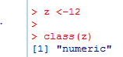
1.2 If I execute the expression z <- 1L in R, what is the class of the object ‘z’?
Answer:
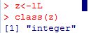

Task 2
2.1 Create a vector z with an objects of 12 and TRUE. What is the implicit coerced class of the object defined by z?
Answer:
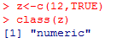
2.2 Create a vector y with an objects of “a” and 1+0i. What is the implicit coerced class of the object defined by y?
Answer:
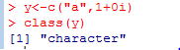
2.3 Convert the vector output from task 2.1 as atomic class LOGICAL.
Answer:
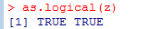
2.4 Convert the vector output from task 2.2 as atomic class COMPLEX.
Answer:
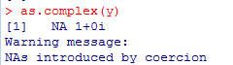

Task 3
3.1 If I have two vectors named as m and n with objects as (110,113, 115, 133) and (113, 212, 818, 1110) respectively, what is produced by the expression rbind(m, n)?
Answer:
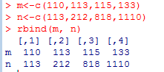
3.2 What is the dimension attribute of the vectors m and n from task 3.1?
Answer:

Task 4
4.1 Suppose I have a list defined as z <- list(22, "a", 1+4i, TRUE). What does z[[3]] give me?
Answer:
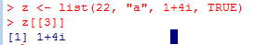
4.2 From the vector z of task 4.1, create a self describing name for each objects according to their atomic class.

Task 5
5.1 Suppose I have a vector z <- 10:40 and a vector y <- 3. What is produced by the vectorized add operations?
Answer:
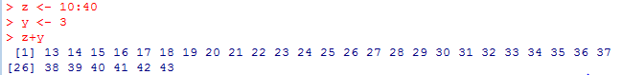
5.2 From task 5.1, what is produced by the vectorized multiply operations?
Answer:

Task 6
6.1 Suppose I have a vector x <- c(117, 114, 14, 15, 113, 112, 110) and I want to set all elements of this vector that are less than 16 to be equal to 1. What R code achieves this?
Answer:
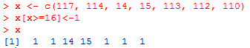

6.2 From the output of task 6.1, deparsed the R object and named it as sona.R
Answer:
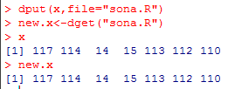
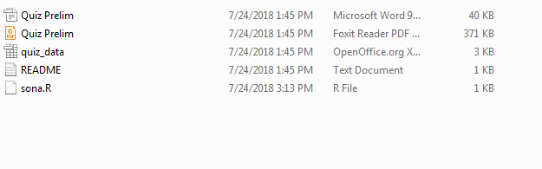
6.3 From the output of task 3.1, deparsed the R object and named it as suna.R
Answer:
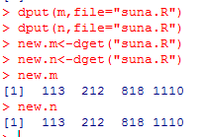
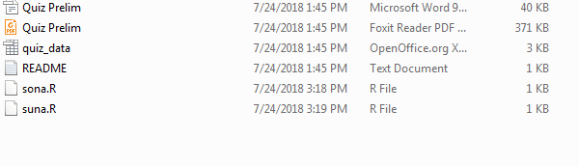

Task 7
7.1 Read the quiz_data.
Answer:
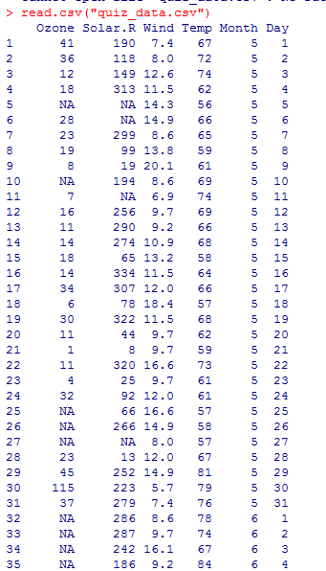

7.2 In the dataset provided for this Quiz, what are the column names of the dataset?
Answer:
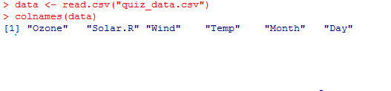

Task 8
Extract the last 18 rows of the data frame and print them to the console. What does the output look like?
Answer:
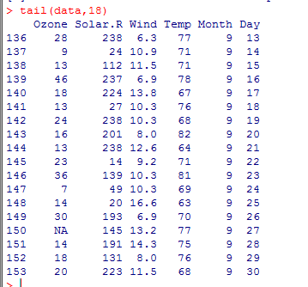

Task 9
9.1 What is the value of Wind in the 82nd row?
Answer:
9.2 Temp in the 32nd row?
Answer:
9.3 Solar.R in the 42nd row?
Answer:
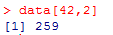

Task 10
10. How many total missing values are in the columns of this data frame?
Answer:
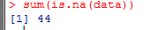
10.2 For Ozone?
Answer:
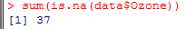

10.3 For Solar.R?
Answer:
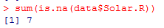
10.4 For Wind?
Answer:
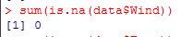
10.5 For Temp?
Answer:
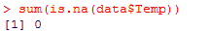

Task 11
11.1 What is the mean for the 20th row – 70th row in Ozone column in this dataset? Exclude missing values (coded as NA) from this calculation.
Answer:

11.2 What is the mean for the 10th row – 50th row in Solar.R column in this dataset? Exclude missing values (coded as NA) from this calculation.
Answer:

11.3 What is the mean for the 12th row – 20th row in Temp column in this dataset? Exclude missing values (coded as NA) from this calculation.
Answer:

Task 12
12.1 Extract the subset of rows of the data frame where Ozone values are above 25 and Temp values are above 70. What is the mean of Wind in this subset?
Answer:
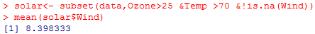

12.2 Extract the subset of rows of the data frame where Ozone values are above 28 and Temp values are above 70. What is the mean of Solar.R in this subset?
Answer:
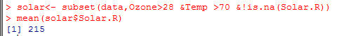

Task 13
13.1 What is the mean of "Temp" when "Month" is equal to 9 and “Day” is equal to 8?
Answer:
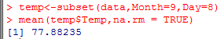

13.2 What is the mean of "Ozone" when "Month" is equal to 9 and “Day” is equal to 8?
Answer:
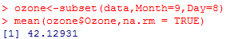

Task 14
14.1 What was the minimum ozone value in each of the month (i.e. Month = 5)?
Answer:
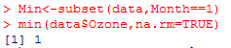
14.2 What was the maximum ozone value in each of the month (i.e. Month = 5) and “Day” is equal to 8?
Answer:
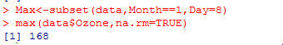

Task 15
15.1 Remove all the NAs in quiz_data.csv.
Answer:
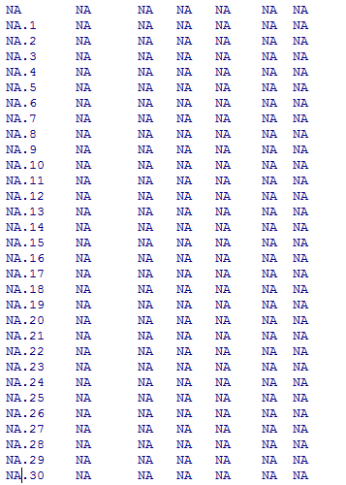
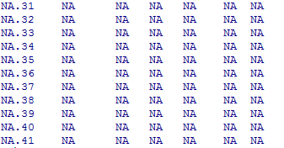

15.2 Save the quiz_data.csv as “cleaned_quiz_data”
Answer:

15.3 Push “cleaned_quiz_data” to your Github together with this document.
Answer:

